**基于机器人的实践方法**

**期末作业**

BLOCKLY实现案例

根据考生座号得出考生座位位置

姓名 ：满勇孝

年级 ：2016级

学院 ：萃英学院

专业 ：生物

学号 ：320160926421

**案例说明：**

期末考试时，知道自己的座号后，都要经过计算才知道自己座位的位置，十分繁琐。通过该算法，可以实现直接通过座号判断自己座位的位置。假设该考场有30个人，分成3列，每列10人。

**界面截图：**

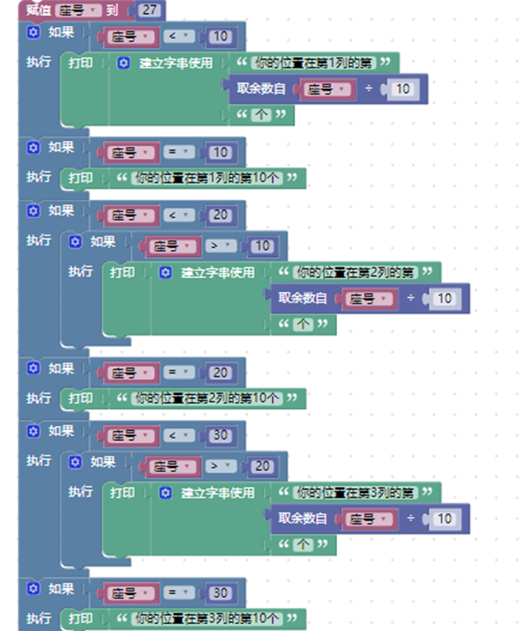

**运行结果：**

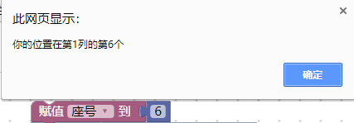

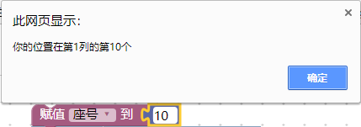

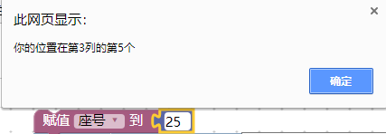

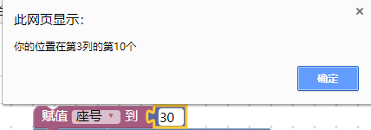

**XML代码：**

<xml xmlns="http://www.w3.org/1999/xhtml">

<variables>

<variable type="" id="dwor%3cS[!Nk#OjE116q">座号</variable>

<variable type="" id="X]oZy:R%R$D@mPJh~tsp">项目</variable>

<variable type="" id="fAXg(E.h/:JXK15],DPt">{textVariable}</variable>

</variables>

<block type="variables_set" id="Ry1Gt_}L@/cU?lTm+7+5" x="238" y="63">

<field name="VAR" id="dwor%3cS[!Nk#OjE116q" variabletype="">座号</field>

<value name="VALUE">

<block type="math_number" id="EhfqqW}M)kNUMB0uxq39">

<field name="NUM">30</field>

</block>

</value>

<next>

<block type="controls_if" id=":M!DZL(|$`U9t+Q/y36~">

<value name="IF0">

<block type="logic_compare" id="/7^DH+TWXgw6U00H}9!Z">

<field name="OP">LT</field>

<value name="A">

<block type="variables_get" id="iM)(;GKB?F~,f@$V~=C]">

<field name="VAR" id="dwor%3cS[!Nk#OjE116q" variabletype="">座号</field>

</block>

</value>

<value name="B">

<block type="math_number" id="6+*9H~;Uuz51@E|1Q#Iy">

<field name="NUM">10</field>

</block>

</value>

</block>

</value>

<statement name="DO0">

<block type="text_print" id="AUQTueu._3G3eQME*(LT">

<value name="TEXT">

<shadow type="text" id="n?3-}/g|YupqT?iUx:jw">

<field name="TEXT">座号为第一列</field>

</shadow>

<block type="text_join" id="pr3pkdt|jBx|IVB#VaMF">

<mutation items="3"></mutation>

<value name="ADD0">

<block type="text" id="%a!)%CaRbt@XPfVce%)i">

<field name="TEXT">你的位置在第1列的第</field>

</block>

</value>

<value name="ADD1">

<block type="math_modulo" id="|,HIC=kgi$`x*;aSZ;/t">

<value name="DIVIDEND">

<shadow type="math_number" id="l/6W#:_Cexwr$kHUgcK/">

<field name="NUM">64</field>

</shadow>

<block type="variables_get" id="HS!3)K$6Uk(=#VWS?`l6">

<field name="VAR" id="dwor%3cS[!Nk#OjE116q" variabletype="">座号</field>

</block>

</value>

<value name="DIVISOR">

<shadow type="math_number" id="pGj75GTlK9b1E.E?zYeq">

<field name="NUM">10</field>

</shadow>

</value>

</block>

</value>

<value name="ADD2">

<block type="text" id="7|!{e?l#O{j*j)sf[1}D">

<field name="TEXT">个</field>

</block>

</value>

</block>

</value>

</block>

</statement>

<next>

<block type="controls_if" id="iNmY(%(0xa5|U)K?zqeK">

<value name="IF0">

<block type="logic_compare" id="ma~P54r=#}$hHu/`PpYJ">

<field name="OP">EQ</field>

<value name="A">

<block type="variables_get" id="xF*aNH1yuLw!tZb,Pk2(">

<field name="VAR" id="dwor%3cS[!Nk#OjE116q" variabletype="">座号</field>

</block>

</value>

<value name="B">

<block type="math_number" id="Wuj4dS4!Cm@ffe}h4Gw9">

<field name="NUM">10</field>

</block>

</value>

</block>

</value>

<statement name="DO0">

<block type="text_print" id="F*$4nDzv^ATHQgNIEJsG">

<value name="TEXT">

<shadow type="text" id="%}Vb6;6,gV#$Z|fLDb=+">

<field name="TEXT">abc</field>

</shadow>

<block type="text" id="64i}?Y{G)0[~3cnJ#]TZ">

<field name="TEXT">你的位置在第1列的第10个</field>

</block>

</value>

</block>

</statement>

<next>

<block type="controls_if" id="oV%+vz.]udma:rehdgK3">

<value name="IF0">

<block type="logic_compare" id="zfc{C[lzn2E!h-M6rsno">

<field name="OP">LT</field>

<value name="A">

<block type="variables_get" id="%N~+:LoO!4.yn!Z?ur|m">

<field name="VAR" id="dwor%3cS[!Nk#OjE116q" variabletype="">座号</field>

</block>

</value>

<value name="B">

<block type="math_number" id="A=G:f;MVFfv{Y:TRZN6Z">

<field name="NUM">20</field>

</block>

</value>

</block>

</value>

<statement name="DO0">

<block type="controls_if" id="WZHzzFW/[wRu0%DBY}QE">

<value name="IF0">

<block type="logic_compare" id="wJh5(qGrvQ*C5FI~g=P8">

<field name="OP">GT</field>

<value name="A">

<block type="variables_get" id="Fd(5]rFS|4a}kOIm.@HS">

<field name="VAR" id="dwor%3cS[!Nk#OjE116q" variabletype="">座号</field>

</block>

</value>

<value name="B">

<block type="math_number" id="DCxP{lZ:72!oIB]RduS{">

<field name="NUM">10</field>

</block>

</value>

</block>

</value>

<statement name="DO0">

<block type="text_print" id="w41Q2+Iz@il)@t2`9u3)">

<value name="TEXT">

<shadow type="text" id="~Be;]D^);-GX=EmzuzML">

<field name="TEXT">abc</field>

</shadow>

<block type="text_join" id="$I+?jIDU)_yT^g,|*2:l">

<mutation items="3"></mutation>

<value name="ADD0">

<block type="text" id="aHU@G#U-WP#EbAXPZN/d">

<field name="TEXT">你的位置在第2列的第</field>

</block>

</value>

<value name="ADD1">

<block type="math_modulo" id="s?Z,Vd1WCM680[UwQ^,-">

<value name="DIVIDEND">

<shadow type="math_number" id="l/6W#:_Cexwr$kHUgcK/">

<field name="NUM">64</field>

</shadow>

<block type="variables_get" id="%8OY*@c~iOJu35:YRM4/">

<field name="VAR" id="dwor%3cS[!Nk#OjE116q" variabletype="">座号</field>

</block>

</value>

<value name="DIVISOR">

<shadow type="math_number" id="m`qMd7t]|axBqRkg3kz:">

<field name="NUM">10</field>

</shadow>

</value>

</block>

</value>

<value name="ADD2">

<block type="text" id="(({cfwOvrBwLq-X0tVlY">

<field name="TEXT">个</field>

</block>

</value>

</block>

</value>

</block>

</statement>

</block>

</statement>

<next>

<block type="controls_if" id="4)EC^]ONB;-uVVfCQeEz">

<value name="IF0">

<block type="logic_compare" id="=Dgtb[/x4mI=(raJTb:?">

<field name="OP">EQ</field>

<value name="A">

<block type="variables_get" id="yM;v/?{t(Q%;-NnI]Gh4">

<field name="VAR" id="dwor%3cS[!Nk#OjE116q" variabletype="">座号</field>

</block>

</value>

<value name="B">

<block type="math_number" id="PhY;%}(=fB*Ri==*F%rL">

<field name="NUM">20</field>

</block>

</value>

</block>

</value>

<statement name="DO0">

<block type="text_print" id="o2lcBv8|%]P13G,t85#4">

<value name="TEXT">

<shadow type="text" id="%}Vb6;6,gV#$Z|fLDb=+">

<field name="TEXT">abc</field>

</shadow>

<block type="text" id="c~;7o1r0d;QutC:V@%^r">

<field name="TEXT">你的位置在第2列的第10个</field>

</block>

</value>

</block>

</statement>

<next>

<block type="controls_if" id="Gwlk5^nnmnGHAg7q`#WD">

<value name="IF0">

<block type="logic_compare" id=";~rM6F(2=Aif+];8w:=s">

<field name="OP">LT</field>

<value name="A">

<block type="variables_get" id="/TOlr-3$2k6!}H}cc,$b">

<field name="VAR" id="dwor%3cS[!Nk#OjE116q" variabletype="">座号</field>

</block>

</value>

<value name="B">

<block type="math_number" id="7sH2*?8?C$$Bf5:5Xx~]">

<field name="NUM">30</field>

</block>

</value>

</block>

</value>

<statement name="DO0">

<block type="controls_if" id="pcs[BRD(?azLO,q2rU!z">

<value name="IF0">

<block type="logic_compare" id="F!Wk:89t^X|(u6H{R?NZ">

<field name="OP">GT</field>

<value name="A">

<block type="variables_get" id="FT{otq-OJZ#YwFU:dL9y">

<field name="VAR" id="dwor%3cS[!Nk#OjE116q" variabletype="">座号</field>

</block>

</value>

<value name="B">

<block type="math_number" id="r4scC@Cw_RqqSeOZ;AFF">

<field name="NUM">20</field>

</block>

</value>

</block>

</value>

<statement name="DO0">

<block type="text_print" id="XMR:be;+Knih{V)0((M~">

<value name="TEXT">

<shadow type="text" id="~Be;]D^);-GX=EmzuzML">

<field name="TEXT">abc</field>

</shadow>

<block type="text_join" id="a*88g~ov$@JHEwi^ejAa">

<mutation items="3"></mutation>

<value name="ADD0">

<block type="text" id="lBnSIi0Y[:lO4y`LJ-m8">

<field name="TEXT">你的位置在第3列的第</field>

</block>

</value>

<value name="ADD1">

<block type="math_modulo" id="+Eq)$KBiOV3|+0BnEfmE">

<value name="DIVIDEND">

<shadow type="math_number" id="l/6W#:_Cexwr$kHUgcK/">

<field name="NUM">64</field>

</shadow>

<block type="variables_get" id="Nvc?E|Q/dDiD{V~B9^H-">

<field name="VAR" id="dwor%3cS[!Nk#OjE116q" variabletype="">座号</field>

</block>

</value>

<value name="DIVISOR">

<shadow type="math_number" id="`93@o2g{|G.xKH?K*kV,">

<field name="NUM">10</field>

</shadow>

</value>

</block>

</value>

<value name="ADD2">

<block type="text" id="{W,3VI7Jr:U9_fS4v/zg">

<field name="TEXT">个</field>

</block>

</value>

</block>

</value>

</block>

</statement>

</block>

</statement>

<next>

<block type="controls_if" id="6X+4ItWnUUYfya0+ggws">

<value name="IF0">

<block type="logic_compare" id="8{Iq[EUx=X`|JtvR:xS8">

<field name="OP">EQ</field>

<value name="A">

<block type="variables_get" id="%?q76Ky(8hj{;.Zv%h9l">

<field name="VAR" id="dwor%3cS[!Nk#OjE116q" variabletype="">座号</field>

</block>

</value>

<value name="B">

<block type="math_number" id="(V:;vbUOAtHHg1e1cX2P">

<field name="NUM">30</field>

</block>

</value>

</block>

</value>

<statement name="DO0">

<block type="text_print" id=".iXHX,?{u,Wy0r=Z(5Ow">

<value name="TEXT">

<shadow type="text" id="%}Vb6;6,gV#$Z|fLDb=+">

<field name="TEXT">abc</field>

</shadow>

<block type="text" id="c|e2[#k5}SMW9CG^;8/[">

<field name="TEXT">你的位置在第3列的第10个</field>

</block>

</value>

</block>

</statement>

</block>

</next>

</block>

</next>

</block>

</next>

</block>

</next>

</block>

</next>

</block>

</next>

</block>

</xml>